How to Access Digital UI 19 Declaration Tool on COVID-19 TERS system

1. **Open the COVID-19 TERS system** [**https://uifecc.labour.gov.za/covid19/**](https://uifecc.labour.gov.za/covid19/)

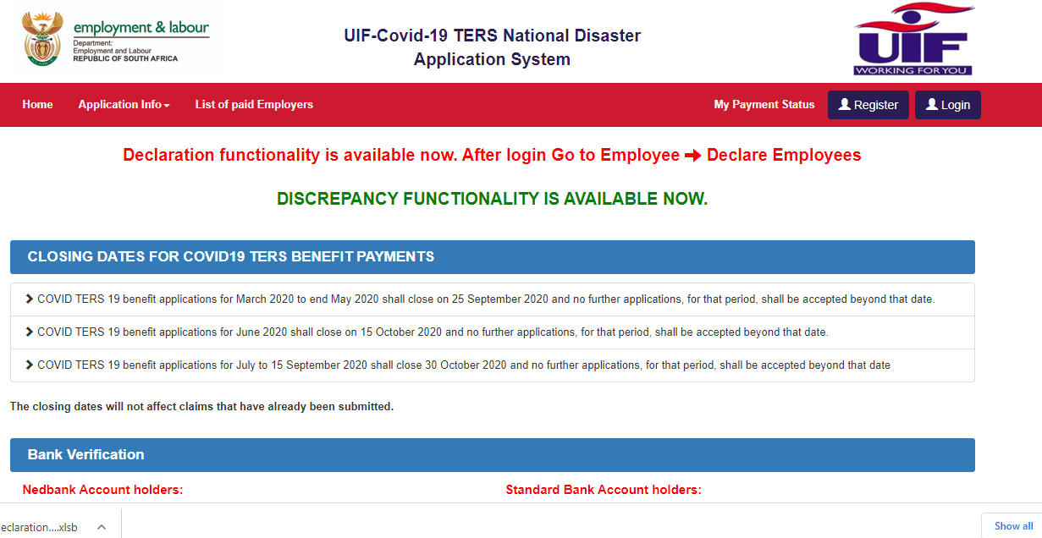

1. **Login using your username and password, then click “Proceed”**

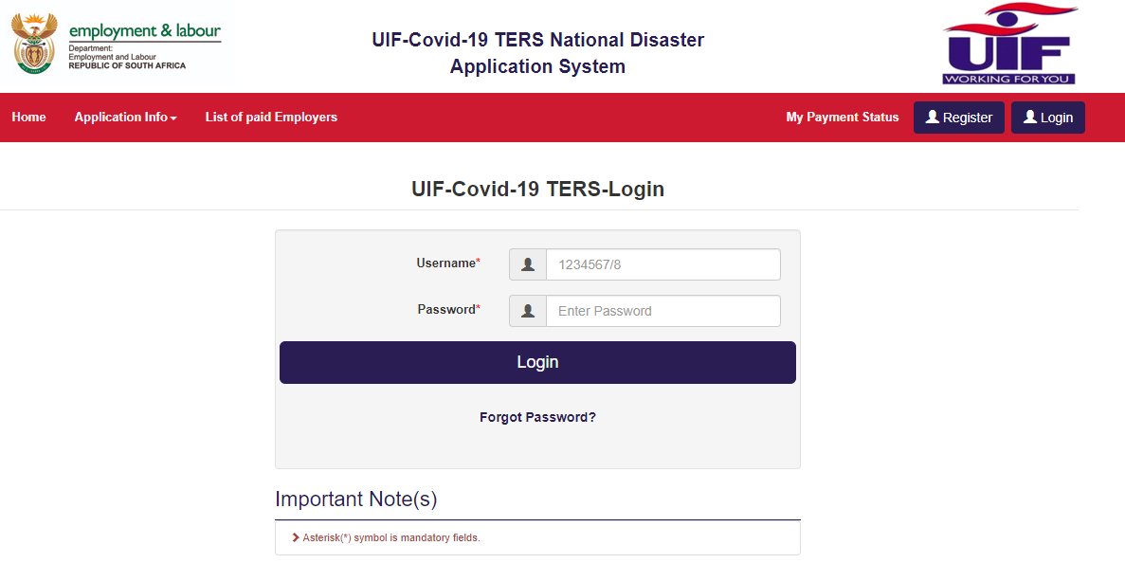

1. **Select “Employee” from the Menu options and then select “Declare Employees (Digital UI.19)”**



**2**

**1**

1. **Click “Digital UI 19 User Guide”**



**3**

1. **Download “Digital UI 19 User Guide”**

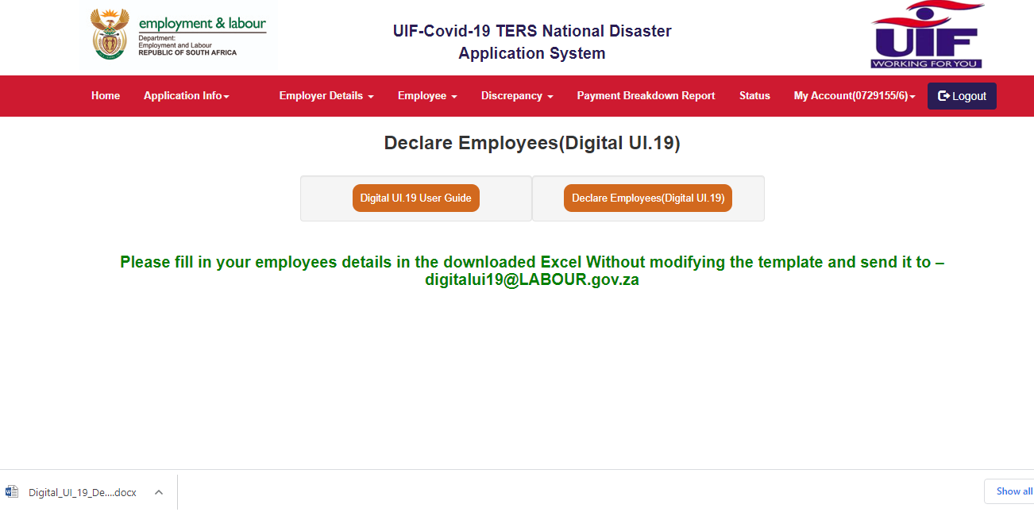

**4**

1. **Click “Declare Employees (Digital UI.19)”.**



**5**

1. **Download and save the Excel file**

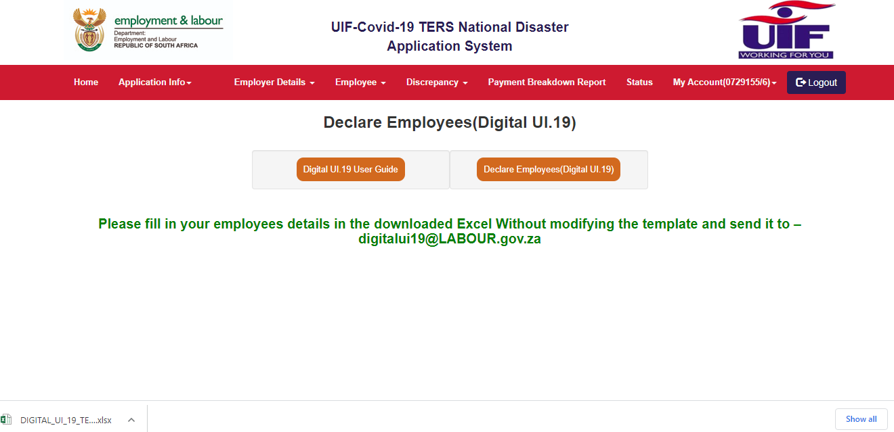

**6**

**How to capture values for Digital UI 19 Declaration**

**Important Instructions:**

1. **User MUST download a new Excel Template from TERS website to submit declarations. Do not copy and create a new file.**
2. **Do not change the structure of the Excel file.**
3. **Leave the PAYE Number blank, if not applicable. Do not delete the column.**
4. **Fields marked with * in the spreadsheet are mandatory and must be completed.**
5. **All date formats should be YYYY/MM/DD (2020/01/15).**
6. **ID Number should not exceed 13 characters and should be without spaces. Adding spaces will discard the record.**
7. **Do not add spaces in any field between values.**
8. **The values of remuneration should not be comma separated. Example – 26000.90 and not 26,000.90.**
9. **The UI Reference number is the 8-digit number in the format (1234567/8) and not the U-number. The UIF reference number within the File should always have ‘/’. The UIF reference number without the / is not recognized.**
10. **No spaces should be anywhere in or between values.**
11. **Only 1 excel file can be accepted per email. Only 1 UIF number data per excel file can be accepted.**
12. **The excel file MUST NOT contain more than 1999 employees.**
13. **The excel file must be sent to** [**mailto:digitalui19@LABOUR.gov.za**](mailto:digitalui19@LABOUR.gov.za)

**COLUMN REQUIREMENTS**

### CREATOR RECORD – SHEET 1 = ONLY 1 LINE ENTRY ACCEPTED

|  |  |  |  |
| --- | --- | --- | --- |
| **Sheet** | **COLUMN_NAME** | **DATA_TYPE** | **MAXIMUM_LENGTH/** |
| **Creator** | Record Type | Character | 4 ( It’s predefined value - UICR) |
|  | Format Type | Character | 2 ( It’s predefined value – U1) |
|  | Version No | Character | 3 ( It’s predefined value – E03) |
|  | UIF Ref Number | Character | 9 (including ‘/’ character) |
|  | Test Live Indicator | Character | 4 ( It’s predefined value - LIVE) |
|  | ID Number | Numeric | 13 digits |
|  | Contact Number | Numeric | 10 digits |
|  | e-mail id | Character | 120 |
|  | Payroll month | Numeric | 6 - YYYYMM |
|  |  |  |  |

* **Record Type – COLUMN 1**

The record type can only be UICR. Any other value will cause the entire file to be rejected.

* **Format Type – COLUMN 2**

The format type must be U1. Any other values will cause the entire file to be rejected.

**Version Number – COLUMN 3**

This number must be E03. Any other value will cause the entire file to be rejected.

* **UIF Reference Number – COLUMN 4**

The UIF reference number must be a valid UIF reference number EXAMPLE: 1234567/8.

An invalid reference number will cause the entire file to be rejected. This is the number supplied to each Employer on registration with the Fund and is always used on any correspondence from the UIF.

* **LIVE Indicator – COLUMN 5**

The indicator must be LIVE.

* **Creator/ Employer ID Number – COLUMN 6**

This is a required field. The ID number supplied must be a valid 13 digits, bar coded RSA national ID number.

* **Contact Telephone Number – COLUMN 7**

This is a required field for communication purposes and must be a valid 10-digit telephone number.

* **Creator E-mail address – COLUMN 8**

The creator’s e-mail address must be given. Must be valid with @ and .

* **Payroll Month – COLUMN 9**

This is a mandatory field, which identifies the **processing** month that is being declared. The only acceptable format is CCYYMM. Example: 202010 – indicating the month October 2020. Only one payroll month must be declared per Excel spreadsheet file. An error in this field will cause the entire file to be rejected.

**EMPLOYEE RECORD – SHEET 2 = ONLY UP TO 1999 ENTRIES**

|  |  |  |  |
| --- | --- | --- | --- |
| **Employee** | Record Type | Character | 4 ( It’s predefined value - UIWK) |
|  | UIF Ref Number | Character | 9 (including ‘/’ character) |
|  | ID Number | Numeric | 13 digits |
|  | Surname | Character | 120 |
|  | First Name | Character | 120 |
|  | Date Of Birth | Date | YYYY/MM/DD |
|  | Employment Start Date | Date | YYYY/MM/DD |
|  | Employment End Date | Date | YYYY/MM/DD |
|  | Employment Status | Character | Select one of the option available from dropdown |
|  | Reason for Non-Contribution | Character | Select one of the option available from dropdown, if applicable |
|  | Gross Taxable Income | Numeric | 13,2 (no comma separator OR Space in value) **Must be 13.2** |
|  | Renumeration Subject to UIF | Numeric | 13,2 (no comma separator OR Space in value) **Must be 13.2** |
|  | UIF Contribution | Numeric | 13,2 (no comma separator OR Space in value) **Must be 13.2** |
|  | Branch Code | Character | 10 |
|  | Account Number | Numeric | 20 |
|  | Account Type | Character | Select one of the option available from dropdown |

* **Record Type – COLUMN 1**

The record type can only be **UIWK**. Any other value will cause the record to be rejected. Must be in capital letters.

* **UIF Employer Reference Number – COLUMN 2**

The UIF reference number must be a valid UIF reference number EXAMPLE: 1234567/8. This is the number supplied to each Employer on registration with the Fund and is always used on any correspondence from the UIF.

* **ID Number – COLUMN 3**

This field is mandatory. The ID number supplied must be a valid 13 digits, bar coded RSA national ID number. Please note that this number is the key to the UI system, without which an applicant cannot claim benefits from the Fund. The employee and employer are still obliged to pay contributions in respect of the employee and to furnish details of the employee to the Fund if the employee does not have an ID number.

* **OTHER NUMBER – COLUMN 4 – DO NOT COMPLETE THIS COLUMN UNTIL FURTHER NOTICE. PASSPORT NUMBERS MUST BE DONE ON U-FILING**
* **Personnel/Clock Card Number – COLUMN 5**

This field should contain either the personnel, clock card or payroll number.

* **Surname – COLUMN 6**

This field is required in order to identify the employee.

* **First Names – COLUMN 7**

This field is required in order to identify the employee.

* **Date of Birth – COLUMN 8**

This field is required for statutory reasons, and must be in CCYY/MM/DD format.

* **Date Employed From – COLUMN 9**

This field is required for statutory reasons, and must be in CCYY/MM/DD format. The date must be the date that the employee started work at the employer.

* **Date Employed To – COLUMN 10**

This field is required for statutory reasons, and must be in CCYY/MM/DD format. The date required in this field is the employee’s termination of services date or last working date before maternity or illness date. This date may not exceed the last day of the following processing month, and cannot be less than the date employed ‘from’. If any other employment status is supplied other than ‘active’, then the date employed to is required.

* **Employment Status code – COLUMN 11**

This field is required and contains the employee’s employment status as at the month end.

The following employment status codes are valid:

|  |  |
| --- | --- |
| **Code** | **Description** |
| 01 | Active |
| 02 | Deceased |
| 03 | Retired |
| 04 | Dismissed |
| 05 | Contract Expired |
| 06 | Resigned |
| 07 | Constructively Dismissed |
| 08 | Employers Insolvency |
| 09 | Maternity / Adoption leave |
| 10 | Illness leave |
| 11 | Retrenched |
| 12 | Transfer to another branch |
| 13 | Absconded |
| 14 | Business Closed |
| 15 | Death of Domestic employer |
| 16 | Voluntary Severance Package |
| 17 | Reduced Working Time |
| 19 | Parental Leave |

* **Reason Code for Non-Contribution – COLUMN 12**

The Reason code for non-contribution is a required field if the UIF contribution amount is zero.

The following reasons for non-contribution codes are valid:

|  |  |
| --- | --- |
| **Code** | **Description** |
| 01 | Temporary employees (less than 24 hours per month) |
| 02 | Learners in terms of the skills development act - |
| 04 | Employees who are repatriated at the end of their contract of service |
| 05 | Employees who earn commission only |
| 06 | No income paid for the payroll period |

* **Gross Taxable Remuneration - COLUMN 13**

The gross taxable remuneration must be accumulated from the same remuneration amounts that make up the total reflected on the SARS tax certificate. Note that **100%** of the travel allowance and the public office allowance must be accumulated for this field. Gross taxable remuneration must not be zero **unless** a reason for non-contribution code is present. If an employee only received TERS payment, then the amount would be zero.

* **Remuneration subject to UIF – COLUMN 14**

The remuneration subject to UIF is the remuneration on which the UI contribution has been calculated, and is defined in terms of section 1 of the Unemployment Insurance Contributions Act. This remuneration is normally limited to the **monthly** limit, unless remuneration is received in the current month in respect of processing periods outside of the current month.

This amount is a required field unless the contributor does not contribute to the Fund and the applicable reason code is shown.

* **UIF Contribution – COLUMN 15**

This field contains the total of the employer and the employee UIF contribution in respect of the employee. If present, this amount must be **2%** of the remuneration subject to UIF. This amount is a required field unless the contributor does not contribute to the Fund and the applicable reason code is shown in field 8290.

* **Bank Branch Code – COLUMN 16**

This is the bank branch code where the **employee’s** bank account is held. It is an optional field, which, along with fields 8340 and 8350, will result in more efficient benefit payments if supplied. Valid branch codes as per the ACB specifications should be supplied.

* **Bank Account Number – COLUMN 17**

This is the e**mployees’** bank account number.

* **Bank Account Type – COLUMN 18**

This is the **employee’s** bank account type. The account types as per the ACB specifications are:

1 = Current (Cheque) account.

2 = Savings account.

3 = Transmission account.

EMPLOYER RECORD – SHEET 3

|  |  |  |  |
| --- | --- | --- | --- |
| **Employer** | Record Type | Character | 4 ( It’s predefined value - UIEM) |
|  | UIF Ref No | Character | 9 (including ‘/’ character) |
|  | PAYE Number | Numeric | 10 |
|  | Total Gross Taxable Renumeration | Numeric | 13,2 (no comma separator OR Space in value) **Must be 13.2** |
|  | Total Gross Taxable Renumeration | Numeric | 13,2 (no comma separator OR Space in value) **Must be 13.2** |
|  | Total Renumeration Subject to UIF | Numeric | 13,2 (no comma separator OR Space in value) **Must be 13.2** |
|  | Total UIF contribution | Numeric | 13,2 (no comma separator OR Space in value) **Must be 13.2** |
|  | Total number employees | Numeric | 15 |
|  | Email id | Character | 120 |

* **Record Type – COLUMN 1**

The record type can only be UIEM.

* **UIF Employer Reference Number – COLUMN 2**

The UIF reference number must be a valid UIF reference number EXAMPLE: 1234567/8

This is the number supplied to each Employer on registration with the Fund and is always used on any correspondence from the UIF.

* **PAYE Employer Number – COLUMN 3**

If registered with SARS, the Employer's PAYE-reference number, under which employee’s tax is deducted and paid over to SARS, must be reflected. This number starts with a "7" and must be a valid reference number as supplied by SARS. If the employer is not registered with SARS, then this number will not be present. The number will be 10 digits

* **Total Gross Taxable Remuneration – COLUMN 4**

This is the total of all fields in the associated employees’ records and will be automatically calculated as per sheet 2 employee records.

**Total Remuneration subject to UIF – COLUMN 5**

This is the total of all fields in the associated employees’ records and will be automatically calculated as per sheet 2 employee records.

* **Total UIF Contribution – COLUMN 6**

This is the total of all fields in the associated employees’ records and will be automatically calculated as per sheet 2 employee records.

* **Total Number of Employee records – COLUMN 7**

The total number of employee records must equal the number of employee records supplied. Automated calculation as per sheet 2 employee records.

* **Employer’s e-mail Address – COLUMN 8**

The employer e-mail address must be given. Must be valid with @ and .

General

It is the employer’s responsibility to ensure that the correct information is submitted to the Fund in each declaration. All submissions must comply with this specification. The digital UI19 Excel spreadsheet file does NOT replace the existing way of declaring via U-filing or LIVE payroll declarations NOR does this replace TERS applications. The digital UI19 is only for employer’s businesses that neglected and did not declare their employees on a monthly basis as per the UI ACT.